**Mustaq Ali**

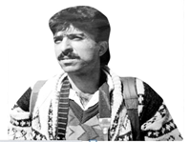

**About:** Mustaq Ali was a photographer for Agene France press and a camera operator for Asian news international. The incident shocked the journalist fraternity of valley, and for Ali’s family the incident was like a disaster that ruined them forever.

**Murdered on:** 07 Sep1995.

**Attack details:** Ali was killed by a parcel bomb in the office of Yousuf Jameel,Srinagar correspondent for the BBC.

**Reason to him target:**  He was a famous journalist and he was died dew to parcel bomb explosion.

**Occupation:** Ali was a photographer for Agency France press and camera operator for Asian news international.

**Belief:** We are yet to come to terms with life.

**URL:** <https://kashmirlife.net/a-smile-cut-short-mushtaq-ali-10802/#:~:text=Twenty%2Dseven%2Dyear%2Dold,Srinagar%20correspondent%20for%20the%20BBC>

<https://www.refworld.org/docid/4e6494e5c.html>

